HOTEL BOOKING ANALYSIS REPORT

1. Business Problem
In recent years, City Hotel and Resort Hotel have experienced high booking cancellation rates. Due to these cancellations, hotels are facing several challenges such as reduced revenue and inefficient utilization of hotel rooms.
As a result, lowering the cancellation rate has become a primary objective for both hotels. Reducing cancellations will help improve room occupancy, increase revenue, and enhance operational efficiency.
The purpose of this analysis is to study hotel booking data and identify the factors that contribute to booking cancellations. By understanding these factors, hotels can implement strategies to reduce cancellations and improve revenue generation.
This report focuses on analyzing hotel booking cancellations and examining other variables that influence hotel revenue and business performance.

2. Assumptions
The following assumptions are considered during the analysis:
- There were no unusual events between 2015 and 2017 that significantly affected the data used in this study.
- The dataset is still relevant and can be used to analyze hotel booking patterns and support business decision-making.
- There are no unexpected negative consequences for the hotel when applying the recommended strategies derived from the analysis.
- The hotels are currently not using any of the proposed solutions suggested in this analysis.
- One of the biggest factors affecting hotel revenue efficiency is booking cancellations.
- Booking cancellations often result in vacant rooms for the reserved period, leading to loss of revenue.
- Customers usually make hotel reservations and cancellations within the same year.

3. Research Questions
This project aims to answer the following research questions:
- What are the key variables that affect hotel reservation cancellations?
- How can hotels reduce the number of booking cancellations?
- How can the analysis help hotels improve pricing strategies and promotional decisions?

4. Hypothesis
Based on the business problem and dataset understanding, the following hypotheses are proposed:
- Booking cancellations are more likely to occur when room prices are higher.
- When there is a longer waiting list, customers tend to cancel their reservations more frequently.
- A large portion of customers book their reservations through offline travel agents rather than direct booking.
5. Analyze the Data and Visualization
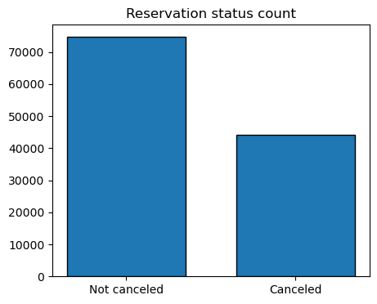
Reservation Status in Different Hotels
- “The accompanying bar graph shows the percentage of reservations that are canceled and those that are not. It is obvious that there are still a significant number of reservations that have not been canceled. There are still 37% of clients who canceled their reservation, which has a significant impact on the hotels' earnings.”
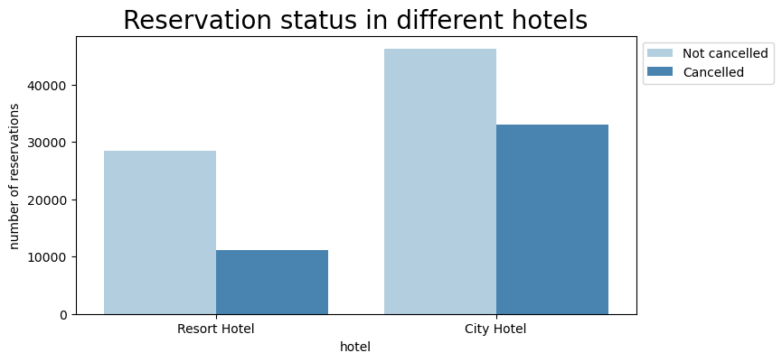
- “In comparison to resort hotels, city hotels have more bookings. It's possible that resort hotels are more expensive than those in cities.”
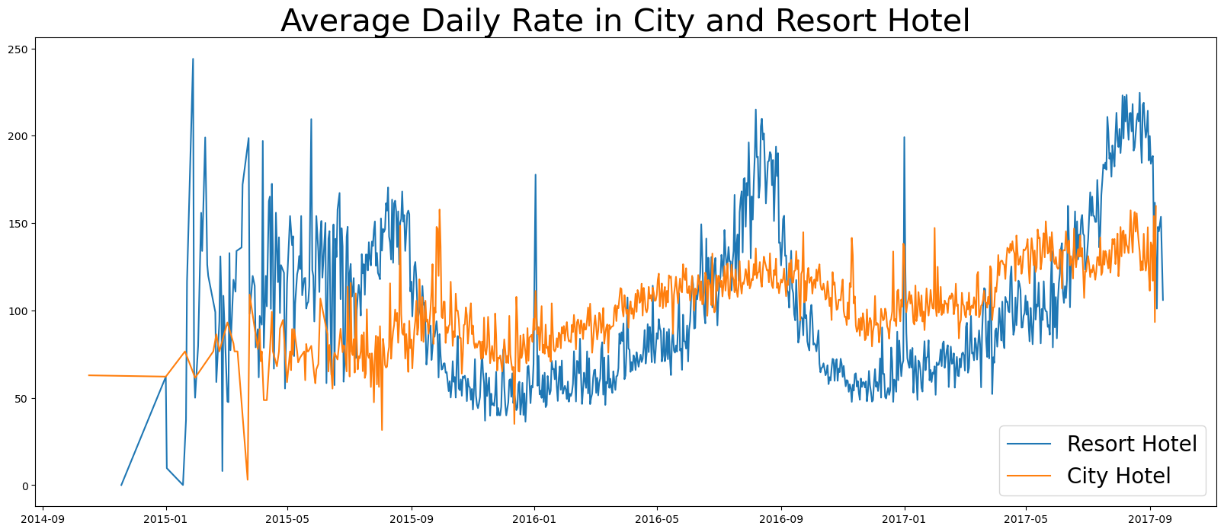
Average Daily Rate (ADR)
- “The line graph above shows that, on certain days, the average daily rate for a city hotel is less than that of a resort hotel, and on other days, it is even less. It goes without saying that weekends and holidays may see a rise in resort hotel rates.”
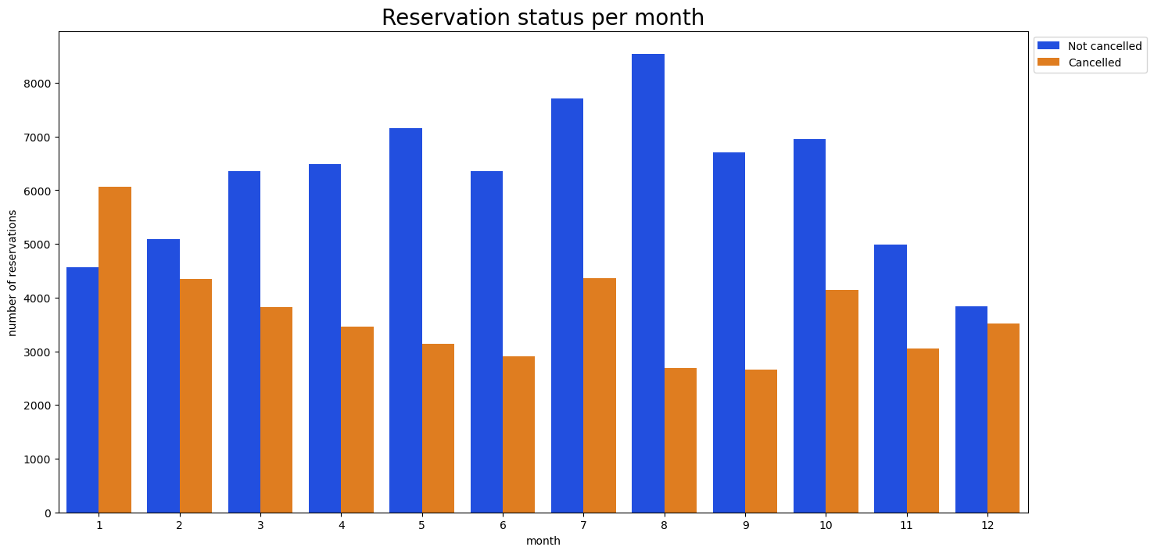
- “We have developed the grouped bar graph to analyze the months with the highest and lowest reservation levels according to reservation status. As can be seen, both the number of confirmed reservations and the number of canceled reservations are largest in the month of August, whereas January is the month with the most canceled reservations.”
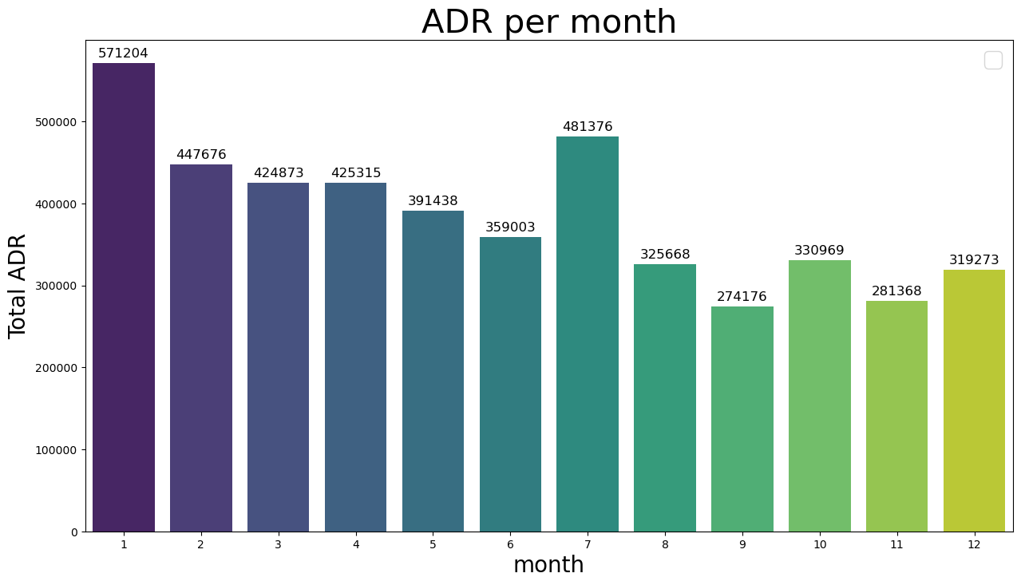

Cancellations and Pricing
- “This bar graph demonstrates that cancellations are most common when prices are greatest and are least common when they are lowest. Therefore, the cost of the accommodation is solely responsible for the cancellation.”
- “Now, let's see which country has the highest reservation canceled. The top country is Portugal with the highest number of cancellations.”
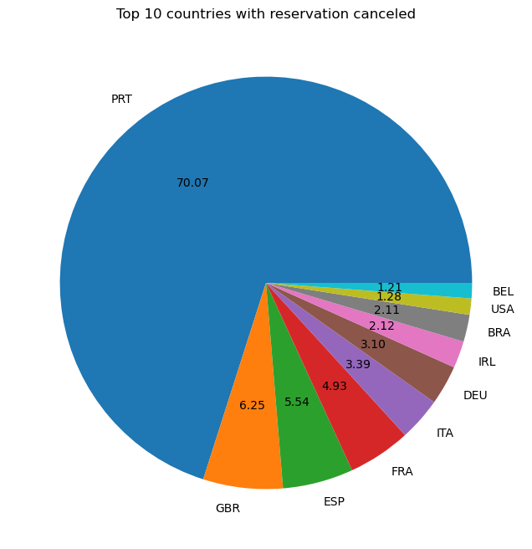
“Let’s check the area from where guests are visiting the hotels and making reservations. Is it coming from Direct or Groups, Online or Offline Travel Agents? Around 46% of the clients come from online travel agencies, whereas 27% come from groups. Only 4% of clients book hotels directly by visiting them and making reservations.”

ADR vs Cancellation
- “As seen in the graph, reservations are canceled when the average daily rate is higher than when it is not canceled. It clearly proves all the above analysis, that the higher price leads to higher cancellation.”
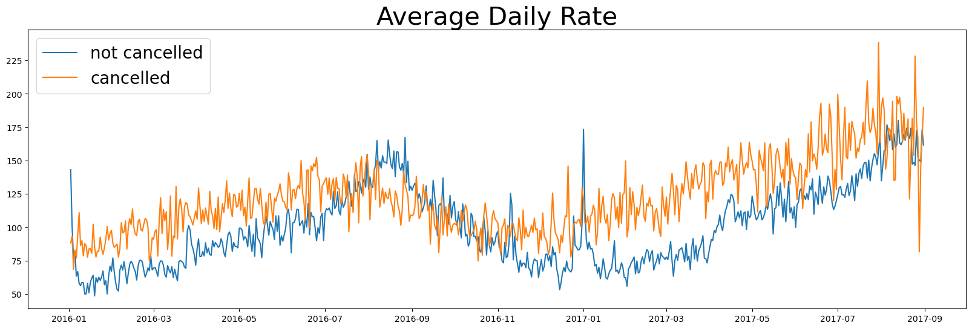
Suggestions
- “Cancellation rates rise as the price does. In order to prevent cancellations of reservations, hotels could work on their pricing strategies and try to lower the rates for specific hotels based on locations. They can also provide some discounts to the consumers.”
- “As the ratio of the cancellation and not cancellation of the resort hotel is higher in the resort hotel than the city hotels. So the hotels should provide a reasonable discount on the room prices on weekends or on holidays.”
- “In the month of January, hotels can start campaigns or marketing with a reasonable amount to increase their revenue as the cancellation is the highest in this month.”
- “They can also increase the quality of their hotels and their services mainly in Portugal to reduce the cancellation rate.”

